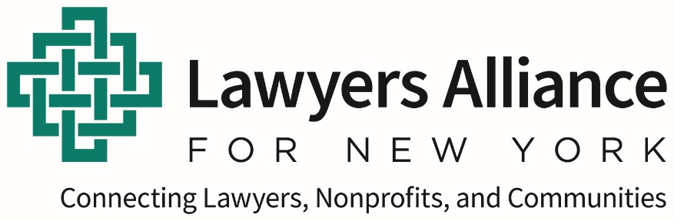
Job Announcement:
Program Assistant - Nonprofit Serving Nonprofits
About Us
Founded in 1969, Lawyers Alliance for New York (www.lawyersalliance.org) is the leading provider of business and transactional legal services for nonprofit organizations and social enterprises that are improving the quality of life in New York City neighborhoods. Our network of pro bono lawyers from law firms and corporations and staff of experienced attorneys collaborate to deliver expert corporate, tax, real estate, employment, intellectual property, and other legal services to community organizations. By connecting lawyers, nonprofits, and communities, Lawyers Alliance helps organizations to provide housing, stimulate economic opportunity, improve urban health and education, promote community arts, and operate and advocate for vital programs that benefit low-income New Yorkers of all ages.
Position
Lawyers Alliance seeks a highly organized and motivated Program Assistant to maintain files, update databases, send out invoices, format documents and conduct other administrative work.
This is an exciting opportunity for a college graduate to use and enhance their organizational, analytical, digital, and communication skills. This role is available immediately and currently reports to the Program and Strategy Director.
Primary Responsibilities:
Support legal program and intake/pro bono placement staff with administrative tasks, including:
- Obtain and organize necessary information and documents from nonprofit organizations and pro bono attorneys.
- Enter and update relevant information regarding nonprofit organizations, pro bono attorneys, legal matters, consultations and billing in our Filemaker database, spreadsheets, and online portals maintained by various funders.
- Conduct research about and engage in outreach to former and prospective clients.
- Support the legal clinic program, including by conducting outreach to eligible nonprofits, reviewing applications and requesting missing materials, and after the clinic following up with participants regarding next steps.
- Format PowerPoint presentations.
- From time to time, schedule and take notes at meetings.
- Other administrative work as needed.

Experience and Attributes
- Bachelor’s degree or equivalent.
- Good organizational, written, and oral communications skills.
- Strong database experience; proficiency using Microsoft Word, Excel, and PowerPoint; and ability to learn new technology quickly.
- Interest in and enthusiasm for New York’s nonprofit sector.
- Ability to work independently and as a supportive team member. Effective at multitasking.
- The ideal candidate works well with varying people and constituencies, shows high attention to data and detail, and is a proactive thinker and a resourceful and personable colleague.
Compensation
This position offers competitive compensation and strong benefits. Anticipated annual salary range is $57,000 to $60,000 depending on experience, and is a non-exempt position.
Hours and Term
This is a full-time position. All employees are expected to work from our midtown Manhattan office at least three days a week.
Next steps
Interested applicants should submit a resume and cover letter through our BambooHR Careers Page as soon as possible. Please include a brief explanation of why you are interested in this position at this time.
Applications will be reviewed on a rolling basis and the position will begin once filled.
Lawyers Alliance for New York is committed to providing a diverse and inclusive environment and is an Equal Opportunity Employer.

